

**Mashwerna**

By

**Nancy Dayekh**

**Graduation Project Report**

**Submitted in Partial Fulfillment of the Requirements for the Degree of**

**Bachelor of Science in Computer Science**

**Department of Computer Science**

**Faculty of Sciences & Arts**

2023-2024



**Mashwerna**

By

**Nancy Dayekh**

**Graduation Project Report**

**Submitted in Partial Fulfillment of the Requirements for the Degree of**

**Bachelor of Science in Computer Science**

**Department of Computer Science**

**Faculty of Sciences & Arts**

**Supervised by:**

**Dr.Ali Abo Molhem**

**Prof. /Dr**………………………

Position and title

2023-2024



**The Report Defense Committee for Nancy Dayekh & Certifies**

**that this is the approved version of the following report**

**Mashwerna**

**APPROVED BY:**

**Supervisor Signature: _______________________________________**

(Name typed under the line)

**Examiner Signature: ________________________________________**

(Name typed under the line)

**Examiner Signature: ________________________________________**

(Name typed under the line)

**Dedication:**

I dedicate this project first and foremost to God, who has guided and inspired us throughout this journey of creation.

To our family - for their constant encouragement, love, and sacrifices that have allowed us to pursue our ambitions and achieve this milestone.

To my professors and mentors - for their guidance, wisdom, and dedication to teaching, which have influenced my academic career and encouraged me to strive for excellence.

To my friends - for their encouragement, humor, and never-ending solidarity, which made the school experience not only useful but also enjoyable and unforgettable.

Last but not least, to Dr. Ali Abu Melhem - for his dedication to providing the best and for guiding me throughout the academic year and the creation of this work.

**Acknowledgments :**

We would like to thank the administration of the Islamic University of Lebanon and the Faculty of Sciences and Arts, represented by Dean Dr. Ali Raad and the Head of the Department of Computer Science. We wish to express our sincere gratitude to our project supervisor, Dr. Ali Abo Molhem, for his guidance, constant support, and encouragement throughout the completion of our final year project. Our completion of this project could not have been accomplished without the support of Dr. Ali Abo Molhem. A warm thank you is extended to Dr. Ali for sharing his resources, opinions, knowledge, experience, and skills in programming and development methodology so generously .

**Abstract:**

Tourism is a vital industry that significantly contributes to the economy of many countries. In our current day, social media became a main source of information for travelers seeking recommendations and reviews about various destinations. However, the current social media platforms often lack dedicated spaces that focus solely on promoting tourism. The purpose of this report is to address the development of a social media app along with an admin panel webpage. The primary objective behind this project is to provide a tourism-oriented platform that fosters user engagement within the travel and blogging community. This app will go beyond standard social media features, allowing users to share travel experiences, interact with other travelers and tourism-related pages, and discover new destinations.

The problem countered by this project is the scarcity of social media platforms that promote tourism which creates a struggle for travelers to find communities that shares their interests and offers valuable insights. Additionally, the existing platforms lack authenticity, unbiased opinions. These platforms market and sponsor content that neglect negative aspects of a location, which portrays an idealized picture of the place. Hence, leading to unrealistic expectations and potential disappointment.

This project aims to address these issues by developing a social media platform specifically designed to promote tourism. The platform will focus on providing travelers with a place to share, chat, discover authentic reviews and information about various destinations. By offering a community of genuine travel enthusiasts and bloggers, the platform will serve as a reliable source for people to explore new places confidently. Alongside with the platform, the accompanying admin panel will serve as a way of filtering and moderating content to keep the app’s space safe, positive, and to enforce the application’s policies.

The app while incorporating standard social media platform features such as likes, comments, and chats, offers some unique features like posting your own experience, moments in the form of an album and it goes by the name ‘activity’. An activity is either a user’s documentation to a certain place (or an event in it) regardless of him owning the place or not, or a capturing of his experience and moments in this place. An Activity is made up of a bunch of media with detailed descriptions, is it basically the pillar of the application where everything from descriptions, critiques, and information is done. Activities similar to posts, can be liked and commented on, also they can be bookmarked.

Furthermore, activities are categorized by their home cities and types each into a city and an activityType respectively. This approach makes the app more organized, the search easier, and the usage friendly.

This project promises quite well results. The app provided users with a well tourist-oriented community that shares true unhindered opinions and offer valuable insights about destinations.

In conclusion, this project faces the void in tourism, blogging, and travelling that the other platforms don’t take put in their considerations. The project’s approach delivers a community that ensures valuable interactions where unbiased, unsponsored endorsements and insights, descriptions, information for famous destinations are give

**Table of Contents**

* **Title Page**
* **Signature Page**
* **Acknowledgments**
* **Abstract**
* **General Introduction**
* **Chapter: 1**

1.1.Introduction

1.2. Objective:

1.3-Scope :

1.4 -Technology Constraints:

1.5- Problem :

1.6-Solutions:

* **Chapter 2** Functional and Conceptional Study**:**

2.1 -Introduction

2.2-Funcational Requirements:

2.3-NonFuncational Requirements:

2.4-UML Use Case Diagram

2.4.1 –Use Case Diagram

2.5- Data Flow Diagrams (DFD)

2.5.1- Context Diagram (DFD level-0)

2.5.2- DFD Level 1 Diagram

* **Chapter : 3** System Design

3.1- ER-Diagram

3.2-Data Dictionary :

ER Diagram Figure **:**

* **Chapter : 4……………..……………………..……………………..……**

Implementation: **……………..……………………..………………….**

4.1-Introducation: **……………..……………………..…………..**

4.2-Mobile Application Part: **……………..……………………..…**

**List of Figures**

Figure 1: User Use Case Diagram:

*Figure 2: Website Context Diagram (DFD Level-0):*

*Figure 3: App Context Diagram (DFD Level-0):*

*Figure 4: Website user DFD Level 1 Diagram*

*Figure 5: App user DFD Level 1 Diagram*

*Figure 6: ER Diagram*

**General Introduction:**

The importance of this project is reflected by the lack of social media platforms that shed light on tourism and exploration directly and fairly. This lack escalates the need to a community where travelers among users can interact with each other, post their honest opinions on different locations, and ex change information. This project ensures all of the above problems are solved by supplying an application that has the same anatomy and backbone of modern social media platforms with some extra perks. Along with an admin panel that is responsible for monitoring and moderating the content for a friendly, positive, and policy abiding environment.

The development process for this project follows a systematic and structured approach. It begins with requirement gathering which is identifying the key features and functionalities of the social media platform and the admin panel side by side with the preferences and necessities of potential users. Then the development phase starts. It involves the creation of a user-friendly interface implementing all the functionalities. Then, the project is tested heavily and sent to users to obtain feedback to allow more improvement. Finally, the project ends with an evaluation of the results, effects, and recommendations for more improvement and better versions to come

**Chapter: 1 Introduction**

**1.1 Introduction:**

This chapter introduces the project's aims, objectives, and scope, along with the technological constraints involved. It outlines the problems that led to the creation of the platform and the solution it offers.

The importance of this project is reflected by the lack of social media platforms that shed light on tourism and exploration directly and fairly. This lack escalates the need to a community where travelers among users can interact with each other, post their honest opinions on different locations, and exchange information. This project ensures all of the above problems are solved by supplying an application that has the same anatomy and backbone of modern social media platforms with some extra perks. Along with an admin panel that is responsible for monitoring and moderating the content for a friendly, positive, and policy abiding environment.

**1.2 Objectives**

Mashwerna, a social media app aims to add a platform where users can interact, get authentic reviews for destinations far from sponsored and paid content. The main objectives of the project are:

* Promote tourism.
* Provide a social media platform for users to share their travel experiences, reviews, and recommendations.
* Offer a user-friendly interface that facilitates the user’s experience.

**1.3 Project Scope:**

Our project addresses the gaps and limitations in the tourism platforms. It is designed to enhance the travel experience for users and blend it with a seamless social media experience.

The platform embraces common social media methodologies (likes, comments, chats …) along with some extra features like rating to help facilitate the user experience and get the most out of both the social media and tourism platforms in one.

**1.4 Technological Constraints:**

Software used: vscode, xampp

Languages: HTML, CSS, SQL, Javascript, Php, dart

Frameworks & Libraries:

* Backend: Laravel
* Frontend: , flutter ,react.js, TailwindCSS

Hardware: Laptop

**1.5 Problem:**

Standard tourism and travel platforms all follow the same pattern causing some problems:

* Lack of interaction between users.
* Lack of authenticity and showing only positive aspects of a place.
* Biased opinions that are based on sponsorships and paid collaborations.

**1.6 Solution:**

By blending social media and tourism, Mashwerna will:

* Provide users a space to chat, interact, and discover various locations.
* Capture their own moments and experiences in certain locations.
* Share their own businesses on the platform.
* Rate and review destinations.

Serve authentic reviews, as the reviews are only from true users and no sponsored content will be available

**Chapter: 2 Functional and Conceptional Study**

**2.1 Introduction**

This chapter outlines both the functional and non-functional requirements for the project. Additionally, it presents UML use case and data flow diagrams with all relevant details.

**2.1. Functional Requirements**

2.2.1 User

* Signup: to access all features, guests should register and login. Otherwise, they can only view the app and search.
* Login: users must login to access their profiles.
* Activities: users can crud (create, read, update, delete) their own activities and view other users’ activities. Also, they’re able to like, comment on, and bookmark them.
* Cities: users are able to view main cities and browse their activities.
* Search: users can choose their type (restaurants, hotels ...) and search based on the city name.
* Chats: users can send messages and chat with other users.
* Rating: users can give a rating out of 5 to any other user with a feedback.

2.2.1 Admin

* Users: admins can view and delete users that violate the terms, also they can promote them to admins.
* Activities: admins can view and delete inappropriate activities.
* Comments: admins can view and delete inappropriate comments.
* Rating: admins can view and delete inappropriate ratings.
* Cities: admins can crud (create, read, update, delete) cities.
* Activity Types: admins can crud (create, read, update, delete) Activity Types.
* Search: admins can search for users, cities, Activity Types, and activities and view each.

2.2.1 Super Admin

* A super admin has all functionalities of a normal one in addition to the ability of promoting or demoting users or admins respectively.

**2.3 Non-functional Requirements**

**2.3.1 Security**

* Emails: email forms are checked during registration and login.
* Authentication: Jwt authentication is used to ensure the encryption of every request from and to the server.

Passwords: passwords are hashed and stored in the database for extra security.

**2.3.2 Performance**

* Response time: the average response time for login and for rendering pages in a stable environment is 1 sec.
* Concurrency: the project should be able to handle a vast number of concurrent users.

**2.3.3 Maintainability**

* **Bug fixes**: the app will be continuously monitored for bugs.
* Enhancements: regular updates will be released with new features and improvements based on user feedback.

**2.4 UML Data Flow and Use Case Diagrams**

**2.4.1- Use Case Diagrams:**

A use case diagram is a graphical depiction of the interactions among the elements of a system. A use case is a methodology used in system analysis to identify, clarify, and organize system requirements. In this section, we will present and describe the application of use case diagrams for both the app and website.

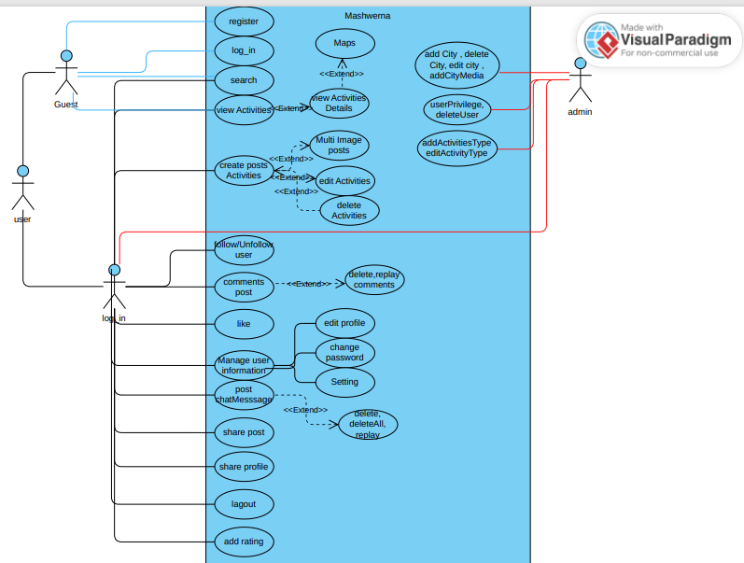

Figure 1: User Use Case Diagram

**2.5-Data Flow Diagrams:**

A data flow diagram (DFD) visually represents how data moves through a system, focusing on the flow of information, inputs, outputs, and storage locations.

**2.5.1 Context Diagram (DFD level-0)**

The Context Diagram represents the system as a single high-level process and displays its relationships with external entities

**2.5.1.1 Website: Context Diagram (DFD level-0)**

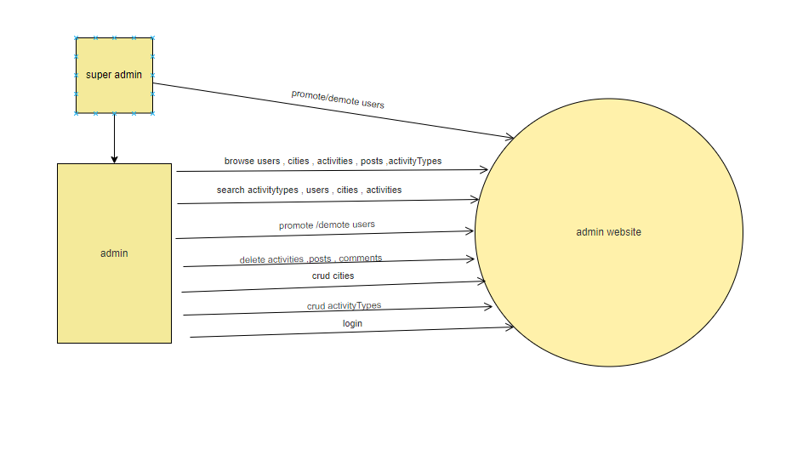

*Figure 2: Website Context Diagram (DFD Level-0)*

**2.5.1.2- Mobile App: Context Diagram (DFD level-0)**

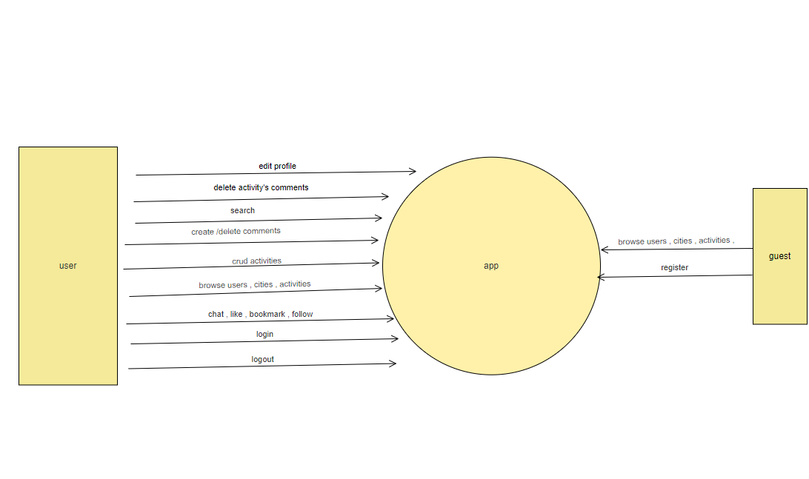

*Figure 3: App Context Diagram (DFD Level-0)*

**2.5.2 -DFD Level 1 Diagram**

Level 1 DFD gives an overview of the full system in more details.

**2.5.2.1 Website: DFD Level 1 Diagram**

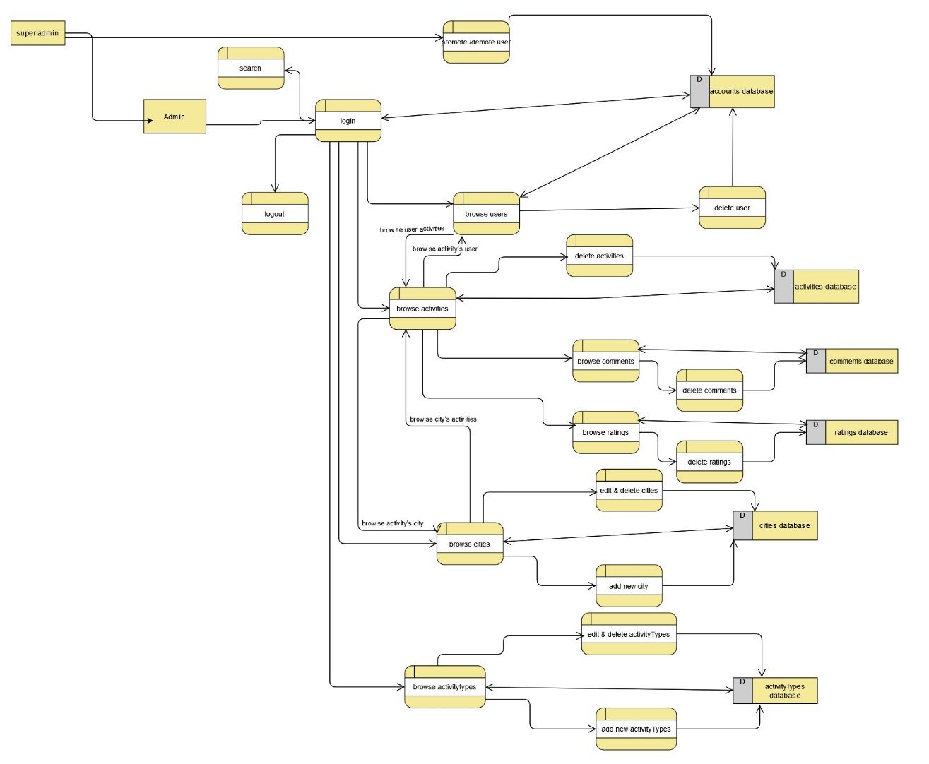

*Figure 4: Website user DFD Level 1 Diagram*

**2.5.2.2 -Mobile App: DFD Level 1 Diagram**

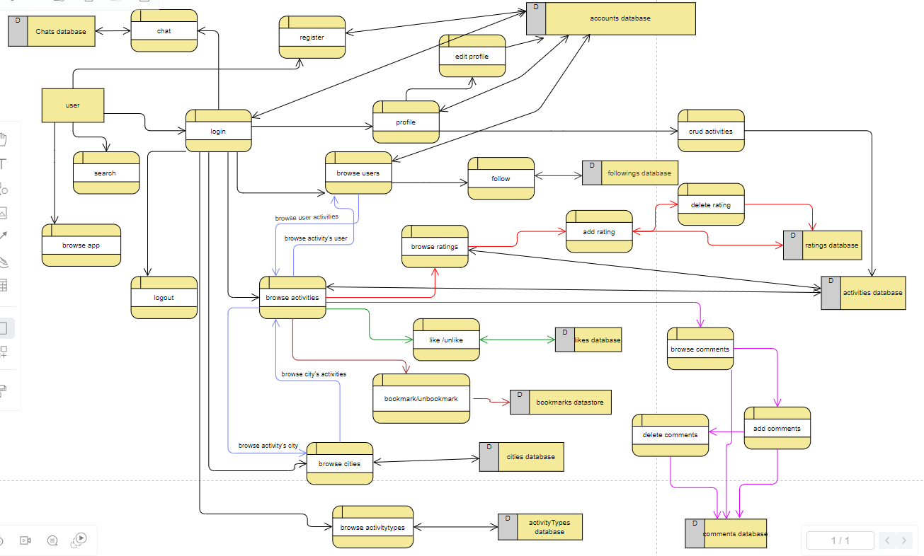

*Figure 5: App user DFD Level 1 Diagram*

**Chapter: 3 System Design**

**3.1 ER Diagram**

The ER diagram represents all the models of the project with their attributes and the relations between them.

**3.2 Data Dictionary**

Table name: users

|  |  |  |  |  |
| --- | --- | --- | --- | --- |
| **Field name** | **Data type** | **Description** | **Key** | **Reference** |
| Id | Int | User ID | PK |  |
| username | Varchar(255) | User Name |  |  |
| Email | Varchar(255) | User Email |  |  |
| password | Varchar(255) | User Password |  |  |
| profile_picture | Varchar(255) | Name of the picture stored |  |  |
| role_id | Int | Indicates user role(1:admin ,2:user) | Fk | Roles(id) |

**Description:** This table stores all information about a user.

Table name: roles

|  |  |  |  |  |
| --- | --- | --- | --- | --- |
| **Field name** | **Data type** | **description** | **Key** | **Reference** |
| Id | Int | User ID | PK |  |
| Role | Int | role | FK | Users(id) |

**Description:** This table stores roles of users.

Table name: followings

|  |  |  |  |  |
| --- | --- | --- | --- | --- |
| **Field name** | **Data type** | **description** | **Key** | **Reference** |
| Id | Int | User ID | PK |  |
| Follower_id | Int | Id of follower | FK | Users(id) |
| Followed_id | Int | Id of followed user | FK | Users(id) |

**Description:** This table stores all information of user followings and followers.

Table name: chats

|  |  |  |  |  |
| --- | --- | --- | --- | --- |
| **Field name** | **Data type** | **Description** | **Key** | **Reference** |
| Id | Int | User ID | PK |  |
| Message | Varchar(255) | Message sent |  |  |
| sender_id | Int | Id of msg sender | FK | Users(id) |
| receiver_id | Int | Id of msg receiver | FK | Users(id) |
| Isdeleted_receiver | Tinyint(1) | Flag to check if receiver deleted the msg |  |  |
| Isdeleted_sender | Tinyint(1) | Flag to check if sender deleted the msg |  |  |

**Description:** This table stores all information of chats.

Table name: notifications

|  |  |  |  |  |  |  |  |  |
| --- | --- | --- | --- | --- | --- | --- | --- | --- |
| **Field name** | **Data type** | | **description** | | **Key** | | **Reference** | |
| Id | Int | | User ID | | PK | |  | |
| notification | Varchar(255) | | Notification sent to user | |  | |  | |
| sender_id | Int | | Id of msg sender | | FK | | Users(id) | |
| receiver_id | Int | | Id of msg receiver | | FK | | Users(id) | |
| activity_id | | Int | | Id of activity | | FK | | activities(id) | |

**Description:** This table stores all information of notifications.

Table name: likes

|  |  |  |  |  |
| --- | --- | --- | --- | --- |
| **Field name** | **Data type** | **description** | **Key** | **Reference** |
| Id | Int | User ID | PK |  |
| Activity_id | Int | Id of liked activity | FK | activities(id) |
| user_id | Int | Id of user | FK | Users(id) |

**Description:** This table stores all information of likes.

Table name: bookmarks

|  |  |  |  |  |
| --- | --- | --- | --- | --- |
| **Field name** | **Data type** | **description** | **Key** | **Reference** |
| Id | Int | User ID | PK |  |
| Activity_id | Int | Id of liked activity | FK | activities(id) |
| user_id | Int | Id of user | FK | Users(id) |

**Description:** This table stores all information of bookmarks

Table name: comments

|  |  |  |  |  |  |  |  |  |
| --- | --- | --- | --- | --- | --- | --- | --- | --- |
| **Field name** | **Data type** | | **description** | | **Key** | | **Reference** | |
| Id | Int | | User ID | | PK | |  | |
| Content | Varchar(255) | | Comment’s content | |  | |  | |
| Activity_id | Int | | Id of liked activity | | FK | | activities(id) | |
| user_id | Int | | Id of user | | FK | | Users(id) | |
| Is_reply | | Tinyint(1) | | Flag to check if comment is a reply | |  | |  | |
| Comment_id | | Int | | Id of original comment if comment is a reply | | Fk | | Commnets(id) | |

**Description:** This table stores all information of comments, comments can be a reply or a normal one.

Table name: comments

|  |  |  |  |  |
| --- | --- | --- | --- | --- |
| **Field name** | **Data type** | **Description** | **Key** | **Reference** |
| Id | Int | User ID | PK |  |
| Content | Varchar(255) | ratings’s content |  |  |
| Rating | Int | Rating out of 5 |  |  |
| Activity_id | Int | Id of rated activity | FK | activities(id) |
| user_id | Int | Id of user that is rating | FK | Users(id) |

**Description:** This table stores all information of ratings, ratings consist of a number and feedback.

Table name: activities

|  |  |  |  |  |
| --- | --- | --- | --- | --- |
| **Field name** | **Data type** | **description** | **Key** | **Reference** |
| Id | Int | User ID | PK |  |
| Activity_name | Varchar(255) | Name of activity |  |  |
| Description | Varchar(255) | Description of activity |  |  |
| Location | Varchar(255) | Location of the activity |  |  |
| Picture | Varchar(255) | Name of profile picture |  |  |
| Likes_count | Int | Number of like on activity |  |  |
| Comments_count | Int | Number of comments on activity |  |  |
| Bookmarks_count | Int | Number of bookmarks on activities |  |  |
| Rate_count | Int | Number of ratings |  |  |
| Rate_sum | Int | Sum of ratings |  |  |
| Rate_average | Double | Rating average |  |  |
| Activity_type_id | Int | Type of the activitiy | Fk | Activity_types(id) |
| City_id | Int | City of this activity | FK | Cities(id) |
| User_id | Int | User of the activity | Fk | Users(id) |

**Description:** This table stores all information of activties.

Table name: activity_pictures

|  |  |  |  |  |
| --- | --- | --- | --- | --- |
| **Field name** | **Data type** | **description** | **Key** | **Reference** |
| Id | Int | User ID | PK |  |
| Media | Varchar(255) | Name of the media |  |  |
| Activity_id | Int | Id of media’s activity | FK | activities(id) |

**Description:** This table stores all information of activity pictures which are photos of an activity.

Table name: activity_types

|  |  |  |  |  |
| --- | --- | --- | --- | --- |
| **Field name** | **Data type** | **description** | **Key** | **Reference** |
| Id | Int | User ID | PK |  |
| Name | Varchar(255) | Name of the activity_type |  |  |
| Icon | Varchar(255) | name of icon |  |  |

**Description:** This table stores all information of activity types which are the categories of an activity.

Table name: cities

|  |  |  |  |  |
| --- | --- | --- | --- | --- |
| **Field name** | **Data type** | **description** | **Key** | **Reference** |
| Id | Int | User ID | PK |  |
| City_name | Varchar(255) | Name of the city |  |  |
| Description | Varchar(255) | Description of the city |  |  |

**Description:** This table stores all information of cities.

Table name: city_pictures

|  |  |  |  |  |
| --- | --- | --- | --- | --- |
| **Field name** | **Data type** | **description** | **Key** | **Reference** |
| Id | Int | User ID | PK |  |
| Media | Varchar(255) | Name of the media |  |  |
| city_id | Int | Id of media’s city | FK | activities(id) |

**Description:** This table stores all information of city pictures which are photos of a city.

**ER Diagram Figure**

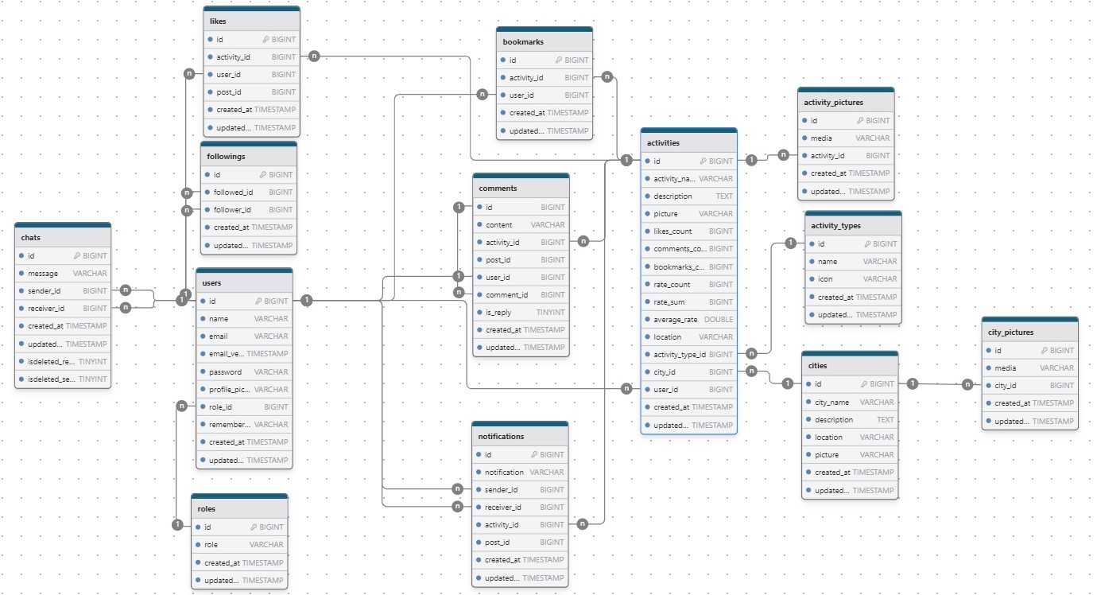

*Figure 6: ER Diagram*

**Chapter Four: Implementation**

This chapter describes the whole the view of our website, it shows the design of my project in addition to stating the main role of each page.

**4.1-Introduction:**

In this section, we delve into the architecture of "Mashwerna," presenting a detailed view of each page within the application and the admin dashboard. Our implementation showcases an interface designed to deliver optimal performance and service. We crafted a straightforward and age-inclusive interface, aiming for simplicity and visual comfort. With user experience as my guiding principle, we ensured that navigating through "Mashwerna" is a smooth and intuitive process, allowing users to transition from one page to the next with ease. This design approach underscores our commitment to providing a hassle-free environment for both casual visitors and administrators managing the backend operations.

Below we are going to view different pages of my application and admin dashboard and how they are going to be in detail.

**4.2-Mobile Application Part:**

**4.2.1-User Login page**

This page users can access their accounts by entering their email and password in the designated fields. The interface is thoughtfully designed for clarity and ease of use, featuring intuitive controls such as the password visibility toggle for enhanced security and convenience. Real-time validation ensures that all required fields are properly filled before submission, prompting users to correct any errors with clear error messages for invalid email or password entries.

Upon successful authentication, users are promptly notified with a subtle yet effective message, confirming their access to the application's main page. The page's sleek design, complemented by a welcoming background image, creates an inviting atmosphere, making the sign-in process both straightforward and visually appealing.

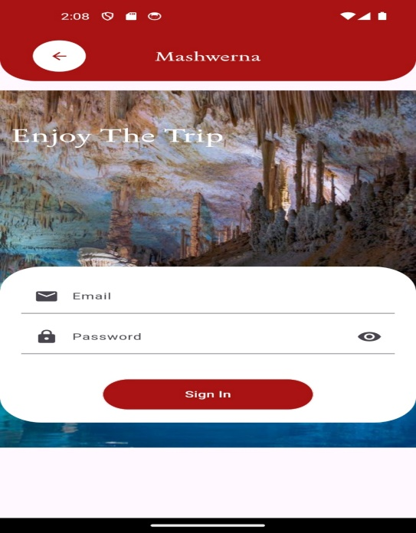

*Figure 7 - Login Page*

**4.2.2-User registration page:**

Welcome to our user-friendly registration page! Here, users can create a new account by entering their email, username, and password. They also have the option to upload a profile picture using the convenient camera icon. Real-time validation ensures that all fields are correctly filled out; any errors prompt users to complete or correct their inputs before submission. Upon successful registration, user information is securely sent to the server, and users are redirected to the Login application page for immediate access.

Passwords must meet security standards, requiring a minimum of 8 characters. Additionally, email addresses are checked to ensure they do not already exist in the database, ensuring data integrity and security. The page features a nice design with a welcoming background image, creating an inviting atmosphere that makes the registration process both straightforward and visually appealing.

This design prioritizes clarity, ease of use, and security, providing a seamless experience for users to join and enjoy our application.

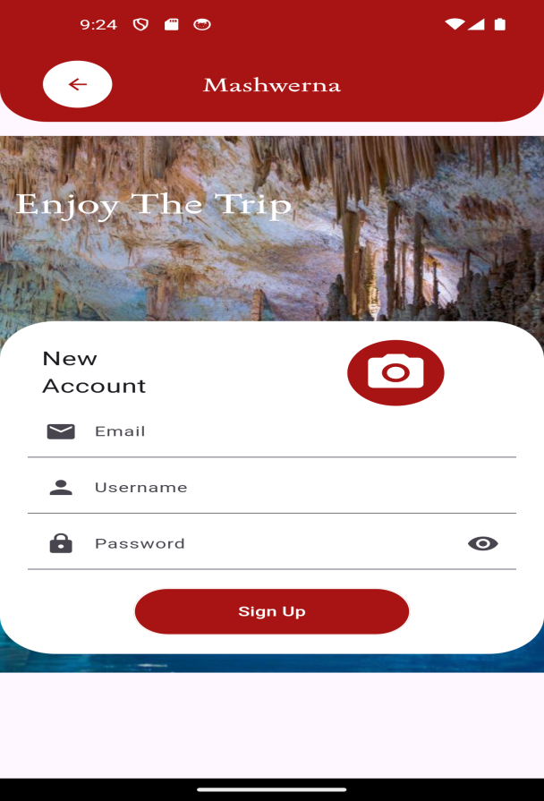

*Figure 8 -signup Page*

**4.2.3-Home Pag**

This page offers a comprehensive user experience with a clear display of categories for easy navigation. It features real-time weather updates for Lebanon, ensuring users are informed at all times. The top navigation bar provides access to user profiles and login, alongside a chat icon for instant messaging. Users can explore various activities presented on the page, each linked to detailed profiles for further engagement. The app supports dynamic content updates with a refresh feature for activities, enhancing user interaction. A bottom navigation bar facilitates seamless navigation across different sections of the application, ensuring a fluid and intuitive browsing experience.

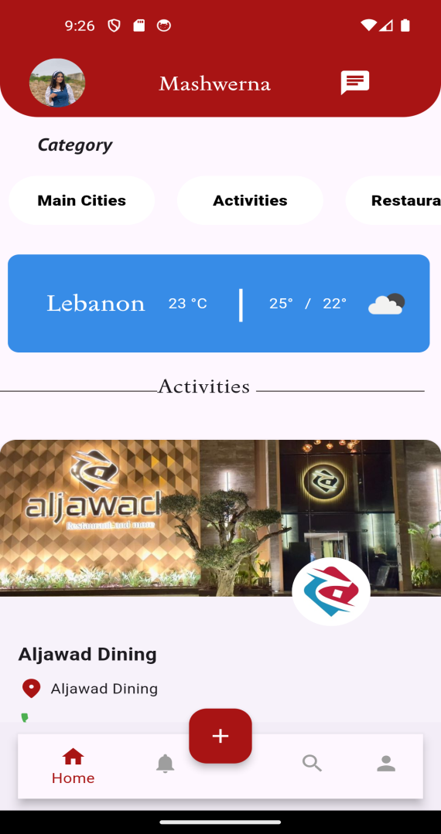

*Figure 9- Home Page*

**4.2.4-Add Post Page:**

this page consists of input fields for capturing activity details, including name, description, contact information, and location. Users benefit from intuitive dropdown menus for selecting activity types and cities, simplifying data entry and enhancing user experience. Additionally, the interface supports seamless image uploads, allowing users to upload either single or multiple images effortlessly. With robust user authentication mechanisms in place, the app ensures secure access to these features, making it a perfect blend of user-friendliness and societal utility

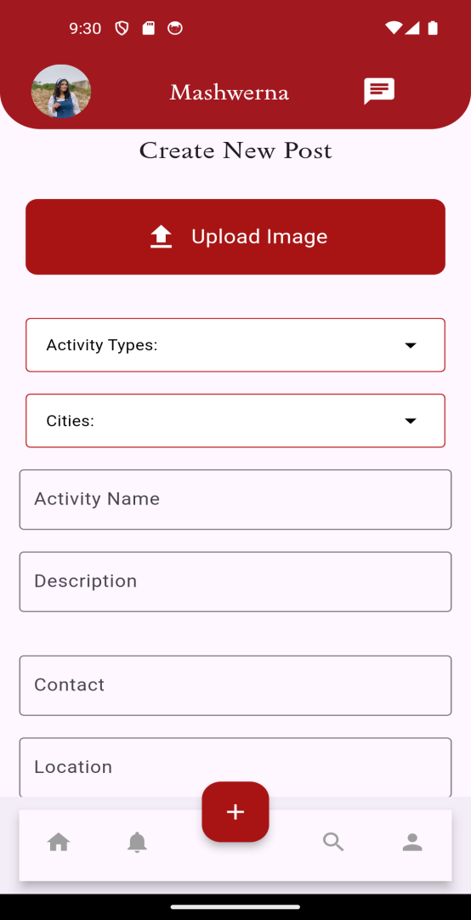

*Figure 10 -Add Post Page*

**4.2.5-Notification:**

The Notifications page enhances user engagement by delivering real-time updates on interactions related to their platform activities. Users receive notifications detailing actions such as likes, comments, replies, and follows. Each notification includes sender details, showcasing their profile picture and name for easy recognition. Users can interact directly from the notification list by following or unfollowing senders and viewing detailed activity information. Tapping on a sender's profile picture or name navigates users to their profile, fostering seamless interaction and exploration. Additionally, users can reply to comments or engage in discussions directly from the notification interface, thereby enriching their participation and connectivity on the Mashwerna.

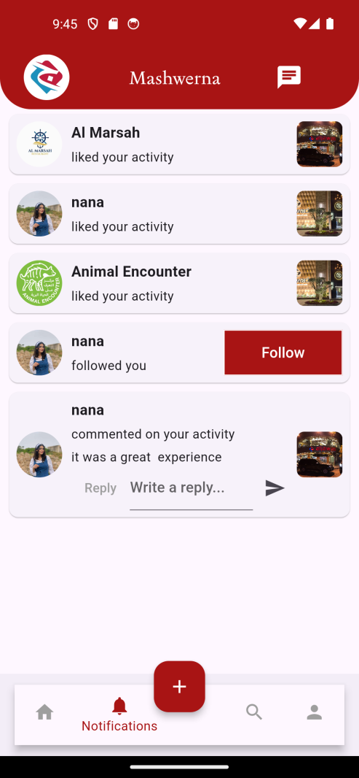

*Figure 11 - Notifications*

**4.2.6-Search:**

The Search page empowers users to explore destinations by entering a city name. Upon entering the city, users can effortlessly navigate through various options such as activities, restaurants, hotels, festivals, and exciting attractions available within that locale. Featuring intuitive buttons and a streamlined search bar, this page ensures a seamless and engaging exploration experience, encouraging users to discover new places and plan their adventures with ease.

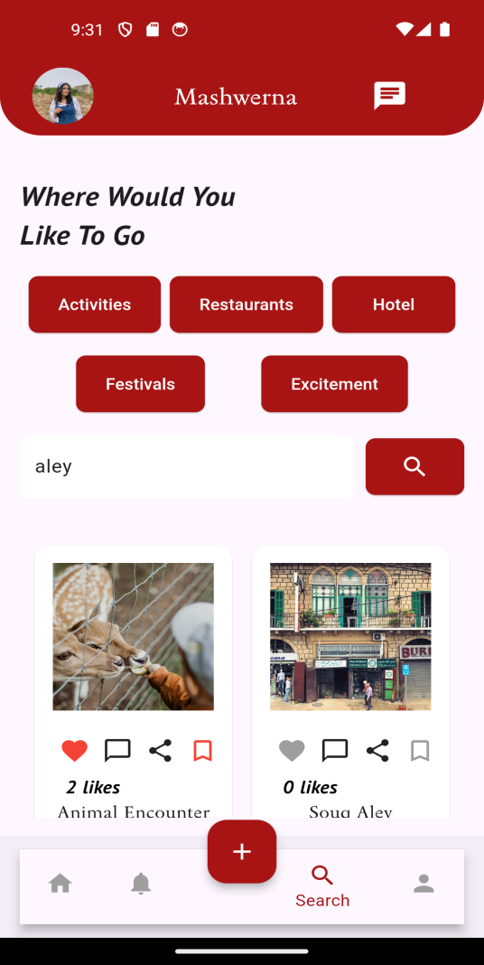

*Figure 12 -Search page*

**4.2.7- profile User:**

The Profile User page offers comprehensive insights into a user's profile, showcasing essential details such as their profile picture, email, name, and engagement metrics like posts, followers, and following. Users can seamlessly navigate to edit their profile or explore settings. This page also facilitates interaction with user activities, enabling actions such as editing, deleting, adding multiple image activities,and sharing posts. With intuitive controls for liking and saving activities, alongside robust sharing capabilities, the Profile User page ensures a dynamic and engaging user experience.

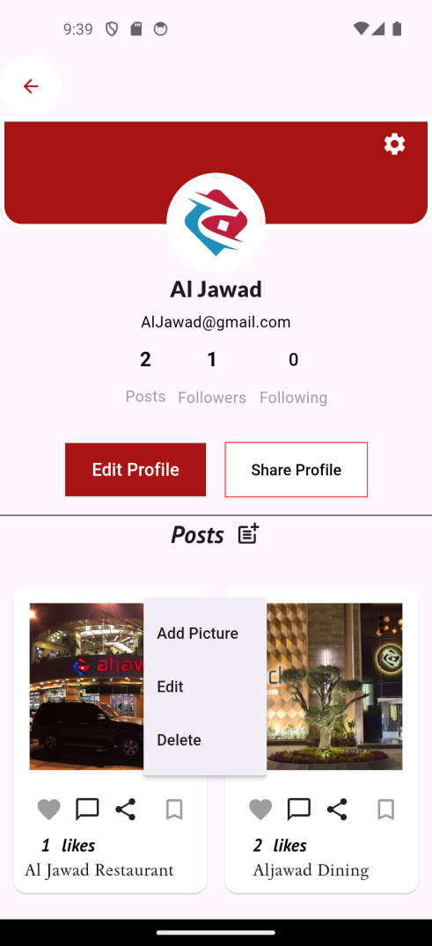

*Figure 13 -**profile User*

**4.2.8-Following Page :**

The Following page allows users to effortlessly view a list of people they are following. When the page loads, it dynamically fetches the list of followings from the server, retrieving and displaying essential details such as profile pictures, names, and emails. Users can simply click on any follower's name to navigate to their detailed profile page. The design ensures a seamless and intuitive user experience, presenting user information in a structured and visually appealing manner. If no followings are found, the page gracefully notifies the user, maintaining a polished and user-friendly interface.

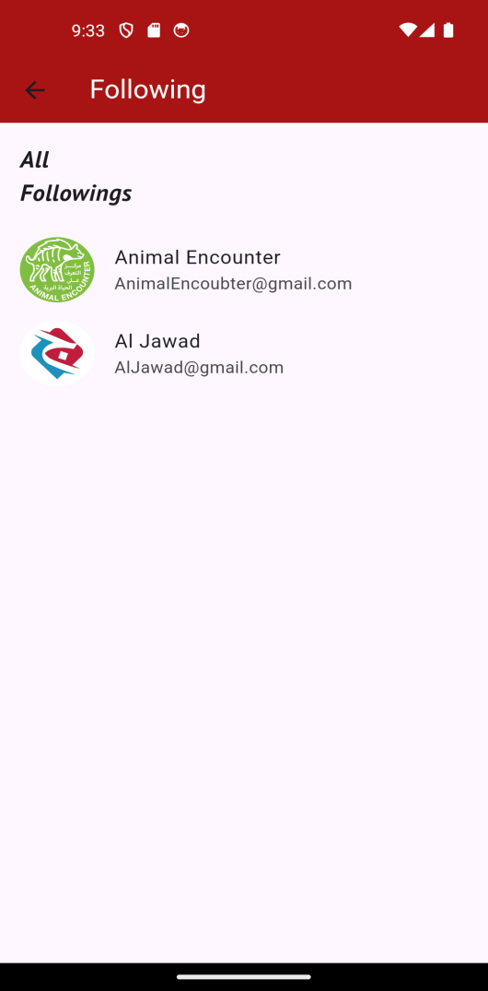

*Figure 14 –Following page*

**4.2.9- Followers Page:**

The Followers page offers users a seamless and engaging experience to view a list of their followers. When the page loads, it automatically fetches the followers' list from the server, retrieving and displaying key details such as profile pictures, names, and emails. Users can click on any follower's name to navigate to their detailed profile page, ensuring an interactive and informative user journey. The design emphasizes an intuitive and visually appealing layout, providing a structured view of the follower information. If no followers are found, the page gracefully informs the user, maintaining a polished and user-friendly interface**.**

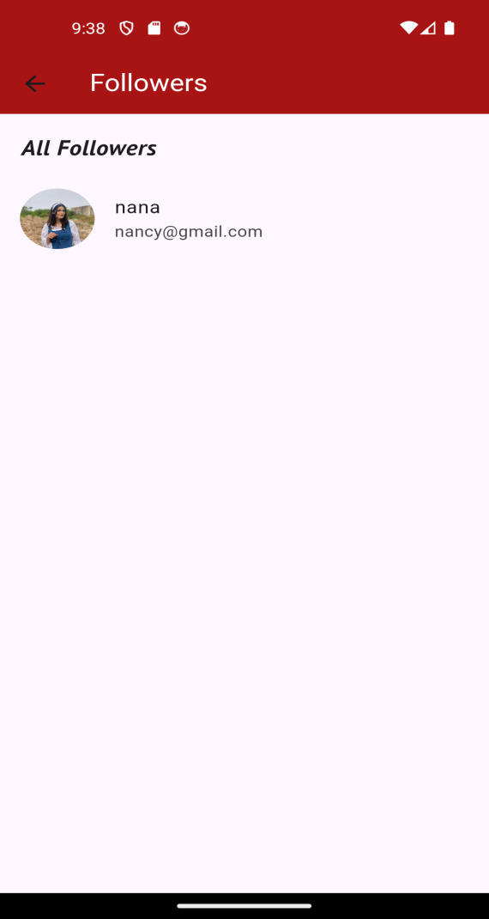

*Figure 15 –Followers page*

**4.2.10- Edit Profile page:**

The Edit Profile page empowers users to update their profile details with ease. It offers intuitive fields for modifying profile information such as name and email, accompanied by an option to upload a new profile picture. Ensuring a seamless experience, users can confidently save changes, which are securely processed and validated, affirming the integrity of their updated information.

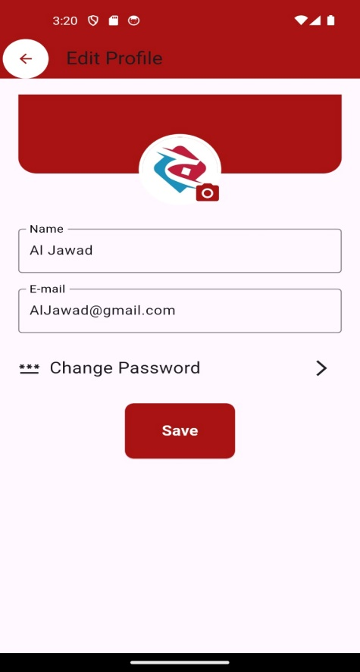

*Figure 16- Edit Profile*

**4.2.11- Edit Password:**

The Edit Password page offers users a secure platform to modify their account credentials. It features dedicated fields for entering the current password, specifying a new password, and confirming it. This process ensures stringent security measures by validating password changes before finalizing them, thereby safeguarding user accounts against unauthorized access.

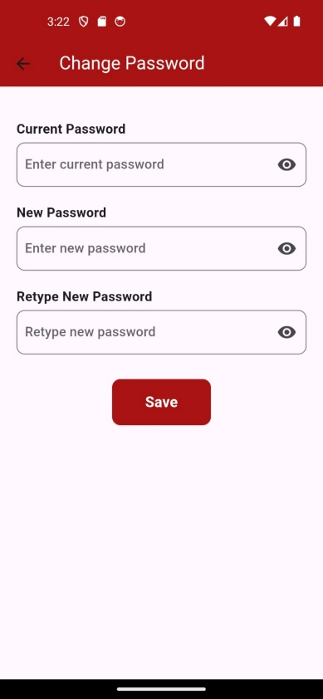

*Figure 17-change password*

**4.2.12-Setting:**

The Settings page provides users with easy access to essential configuration options and functionalities. The page includes options such as Saved, where users can view their bookmarked items. The layout is designed for intuitive use, featuring clear icons and text labels. At the bottom, a prominently displayed logout button allows users to securely log out of their account, redirecting them to the main application page upon successful logout. The design ensures a seamless, user-friendly experience with visually appealing elements and intuitive navigation.

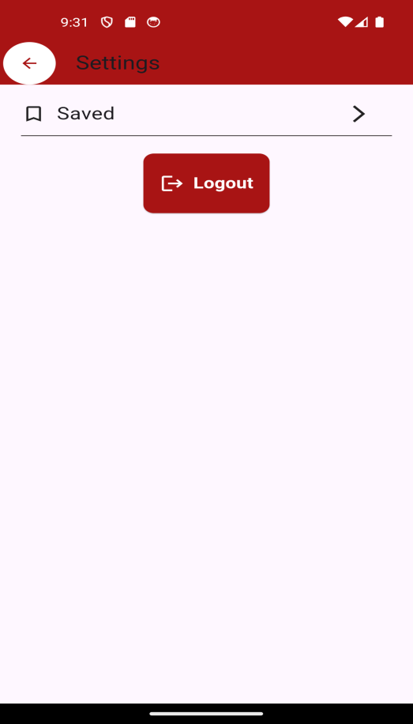

*Figure 18-setting page*

**4.2.13-saved page :**

The User Saved page provides a seamless and visually appealing interface for users to access their bookmarked activities. When the page loads, it verifies the user's token and retrieves the saved activities from the server. The activities are displayed in a grid layout, showcasing attractive images and essential details. Users can effortlessly tap on any activity to view detailed information on a separate page. The design ensures an intuitive user experience with smooth navigation and clear visuals. If there are no saved activities or an error occurs, the page gracefully handles it by displaying an appropriate message or a loading indicator, maintaining a polished and user-friendly interface.

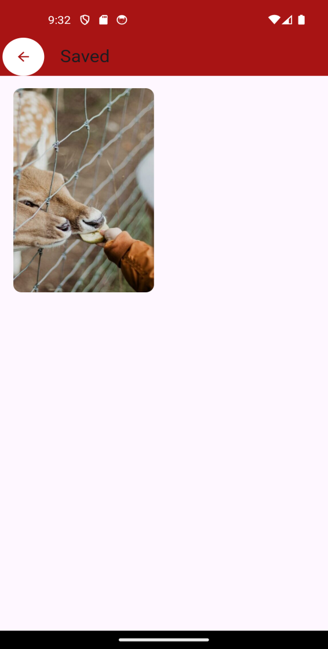

*Figure 19-saved page*

**4.2.14-chat user page:**

The chat user login page displays user profiles showcasing names, profile pictures, and messages from all users who have communicated with the logged-in user. Clicking on a user's name or profile picture seamlessly accesses a chat interface for exchanging messages. This page ensures a streamlined and secure user experience, continually updating message previews through asynchronous operations to reflect the latest conversations. Enhance engagement with real-time messaging capabilities, fostering dynamic interaction.

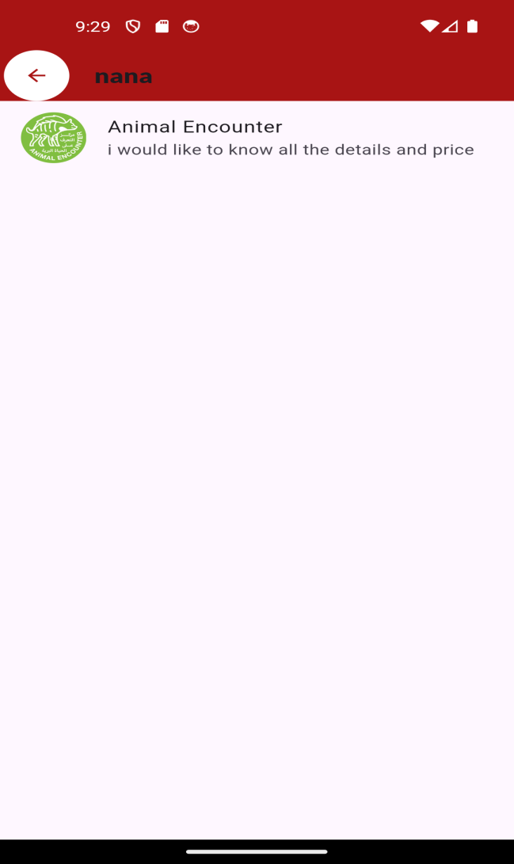

*Figure 20 -**chat user page***:**

**4.2.15- Chats:**

On this page, users can send messages to each other and manage their conversations seamlessly. Each message is displayed with sender details and timestamp, ensuring clarity and context in conversations. Users have the capability to delete individual messages or clear their entire chat history, providing flexibility and control over their interactions. the page guarantees a responsive and secure messaging experience. This approach ensures that users can engage in meaningful conversations while maintaining control over their communication history within the app.

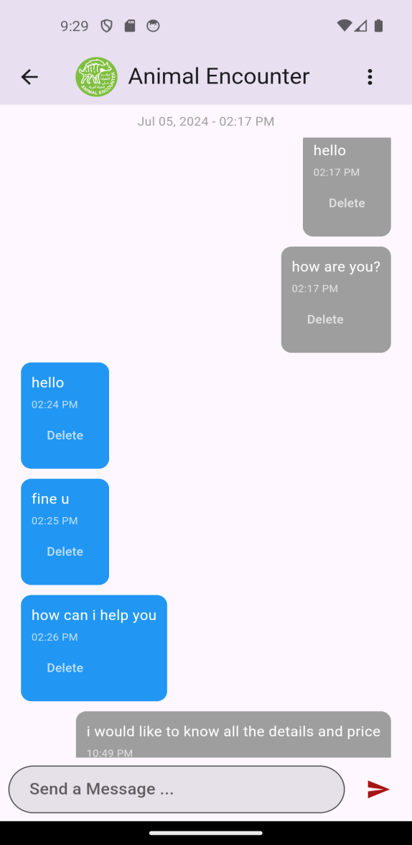

*Figure 21 -**chat page***:**

**4.2.16- view organization pages**

The Main City page in the app is designed to allow users to explore and view activities based on existing areas. Clicking the "More" button allows users to view detailed activities and information for a specific city, and download related activities directly. This easy-to-use and consistent functionality ensures that users have access to city-specific activities, enhancing their experience by providing personalized content**.**

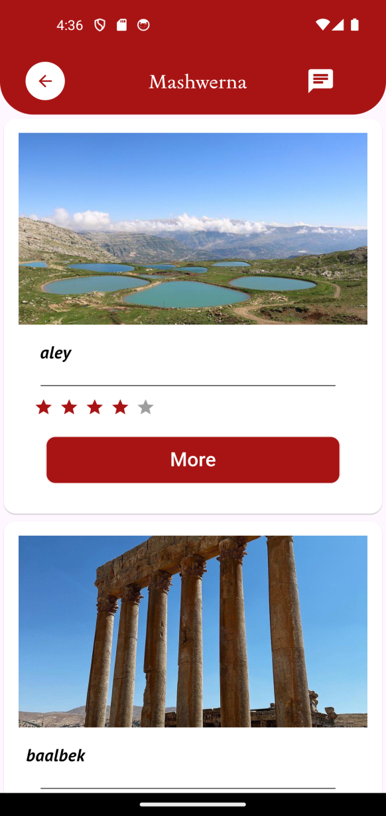

*Figure 22-**view organization pages*

**4.2.17- view Details organization pages**

The Details Cities page is designed to provide users with a seamless and visually appealing experience when exploring city details. It features a high-resolution city image as a backdrop, complemented by an intuitive back button for easy navigation. The city's name is prominently displayed in a stylish font, with a clean divider enhancing the page's structure. A well-presented description follows, ensuring clarity and readability throughout the user's interaction.

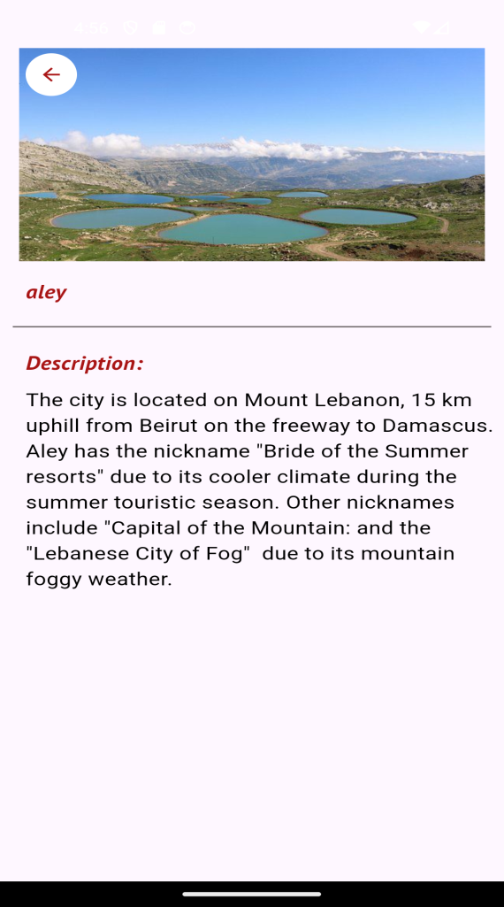

*Figure 23-**view Details organization pages*

**4.2.18- view All Activities pages**

The page allows users to view various activities, hotels, restaurants, excitement options, or festivals. Users can see detailed information about each activity, such as the name, location, and contact details, along with a picture of the activity. Each activity card also displays the profile picture of the user who posted the activity, which users can click to view more information about the poster. The page is designed to provide an engaging and interactive experience, making it easy for users to explore and discover activities that interest them**.**

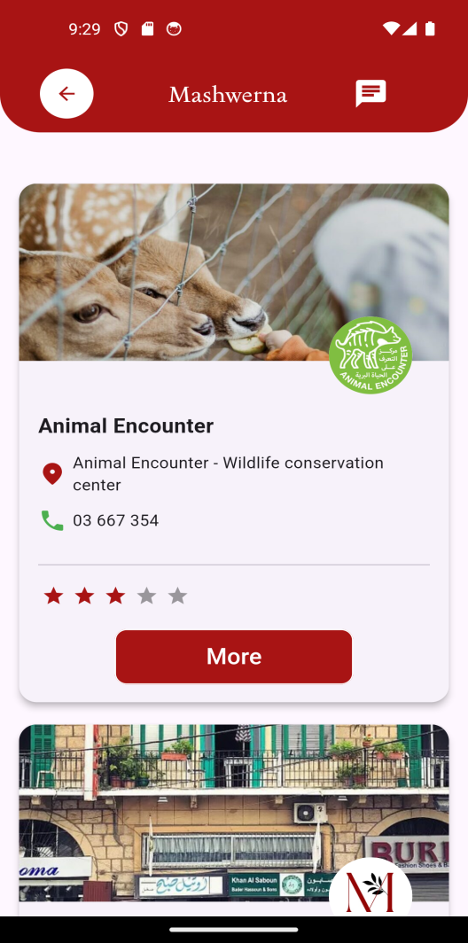 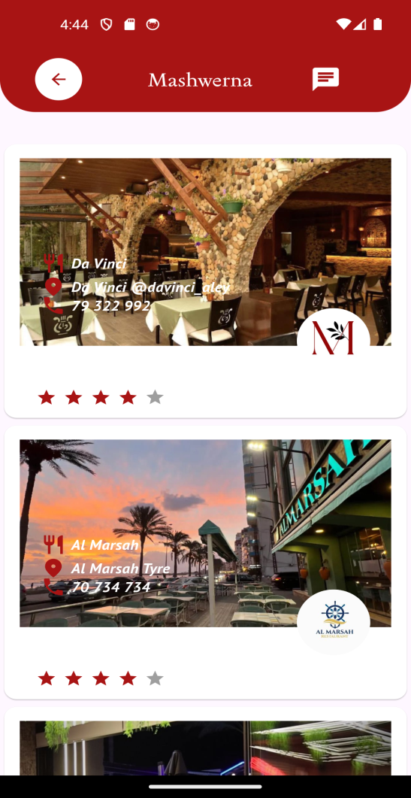

*Figure 24 -**view Activities pages Figure25 -**view Restaurants pages***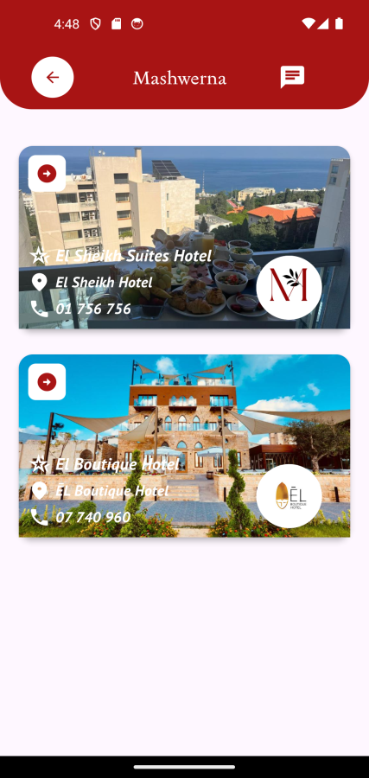 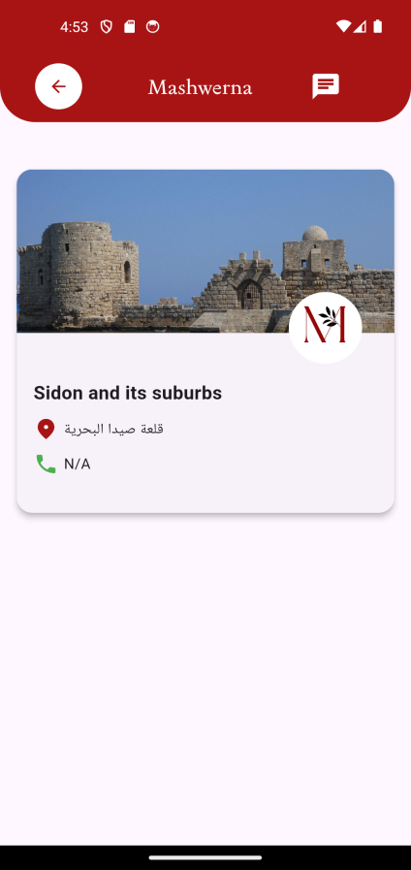 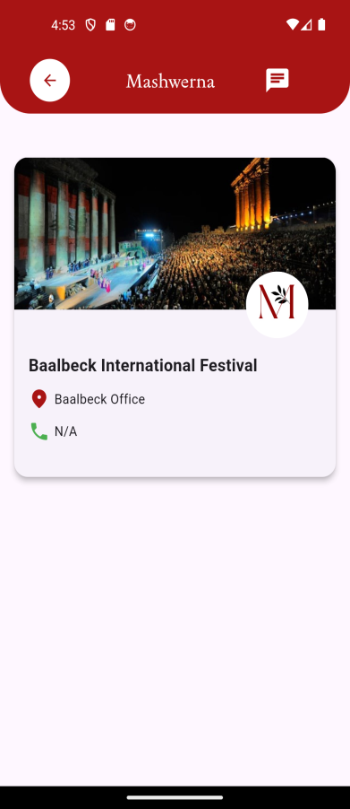**

*Figure 26 -**view Hotel pages Figure 27 -**view Excitement pages Figure 28 -**view Festivals pages*

**4.2.19-Profile Customer page**

The Profile Customer is crafted to present a wealth of information about the customer in an aesthetically pleasing layout. It prominently features the customer's profile picture, name, and email address, ensuring these details are easily accessible and visually appealing. Users can quickly gauge their social presence with counts for followers, following, and posted activities displayed prominently. Interaction is streamlined with intuitive buttons to follow or unfollow other users directly from the page, providing immediate feedback. Additionally, users can engage in direct messaging, facilitating seamless communication. The activities section showcases the user's posted content in a visually engaging grid format, with each item clickable to reveal more details. This design prioritizes clarity, usability, and visual appeal, offering a seamless experience for navigating and interacting with user profiles.

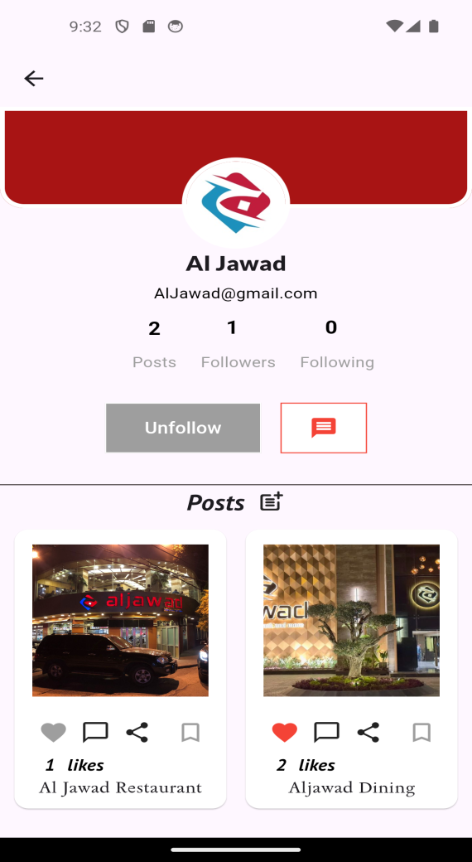

*Figure 29 –customer page*

**4.2.20-view details Activities**

This page presents detailed activity information based on the provided ID. It seamlessly showcases captivating images and encourages user engagement through features like liking, commenting, and effortless sharing across social media platforms. Integrated with Google Maps, the screen offers a visual tour of activity locations, empowering users to explore routes and navigate directly within the app. Furthermore, users can rate activities and share insights through comments, with the average rating prominently displayed. This holistic approach ensures a captivating and interactive user experience, tailored for exploring and engaging with comprehensive activity details.

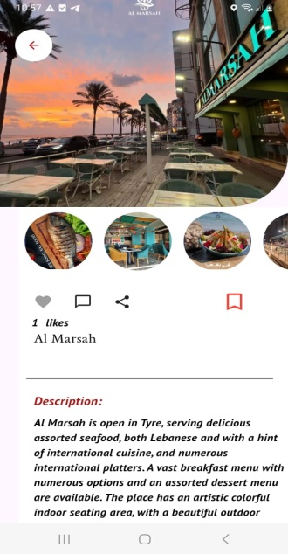 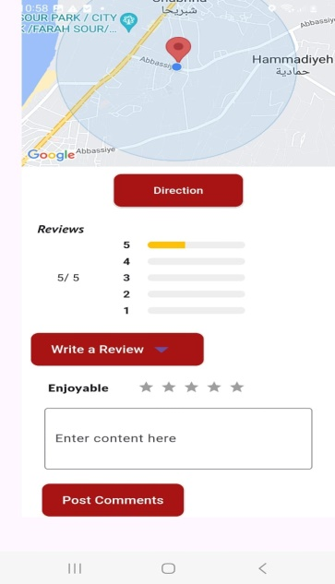 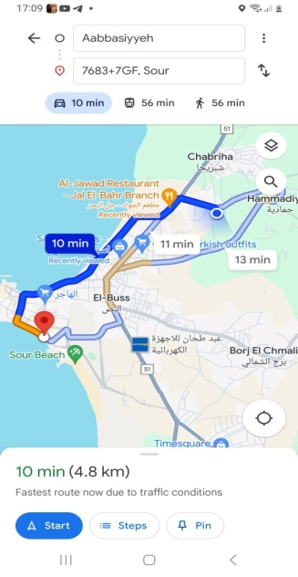

*Figure 30 -**view details Activities*

**4.2.21- Comment page**

This page presents detailed activity comments based on the provided ID Activity, offering users a seamless experience for engaging with community feedback. Each comment is enriched with user profiles, including names and avatars, fostering a personalized interaction. Users can effortlessly reply to comments and add their own, enhancing dialogue and community engagement. Integrated with secure authentication, the page ensures that only logged-in users can participate, promoting a safe and trusted environment. Additionally, users have the ability to delete their own comments, providing control over their contributions. comments are dynamically fetched and updated, ensuring real-time interactions. Overall, this design prioritizes user interaction, security, and real-time updates, providing a robust platform for meaningful engagement and community interaction within the app.

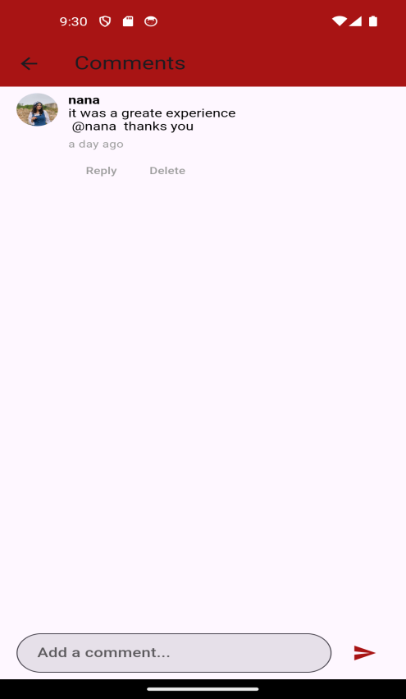

*Figure 31-comment page*

**4.3- Admin Website**

**4.3.1- Introduction**

The website is dedicated for admins to moderate and revise content that is being posted. With the help of the website, admins can search and delete users, activities, activities’ comments, activities’ ratings. Also, admins create/manage the categories that activities rely on (cities, activity types) meaning they have full access over them.

**4.3.2- Login Page**

The login page is very simple it contains the login form with a modest and appealing design. User role is checked when logging in denying normal users from entering accompanied with a notification while allowing admins.

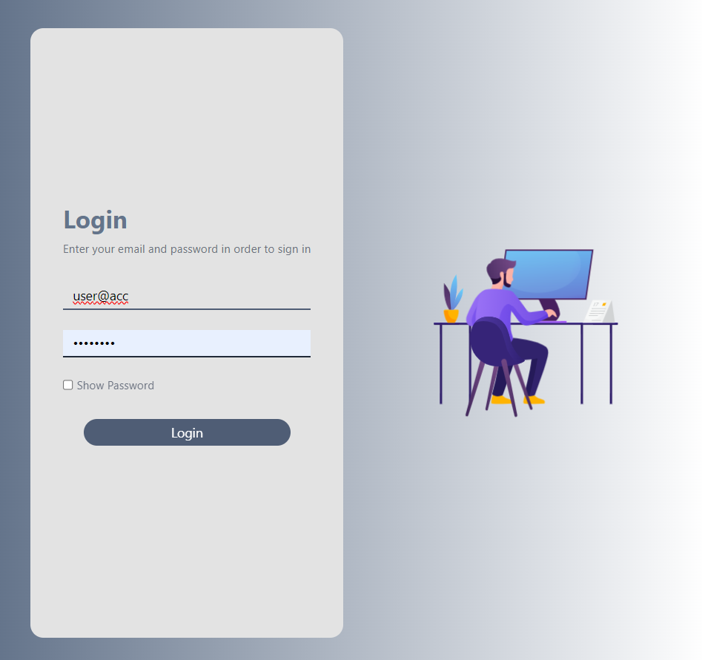

*Figure 32-login*

**4.3.2- Management Page**

The management page wraps it all in a single page. It contains an overview on all elements with search bars specific for each one. Admins can access search and access any element with different privileges for each one.

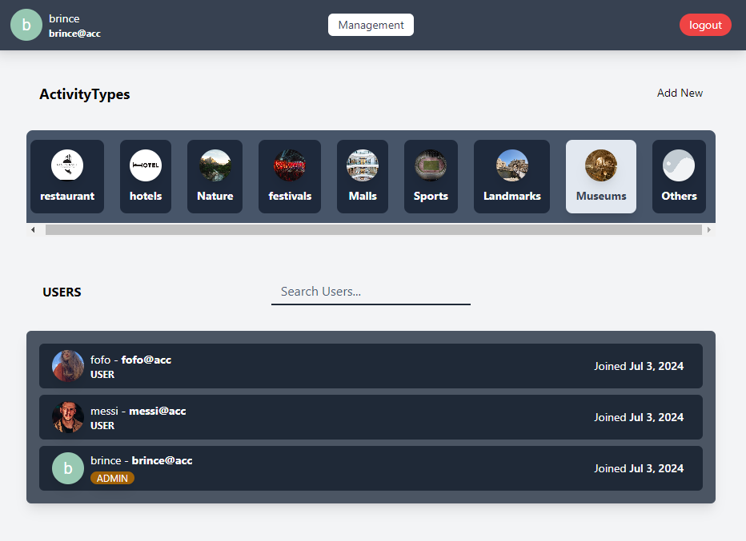

*Figure 33-**Management Page*

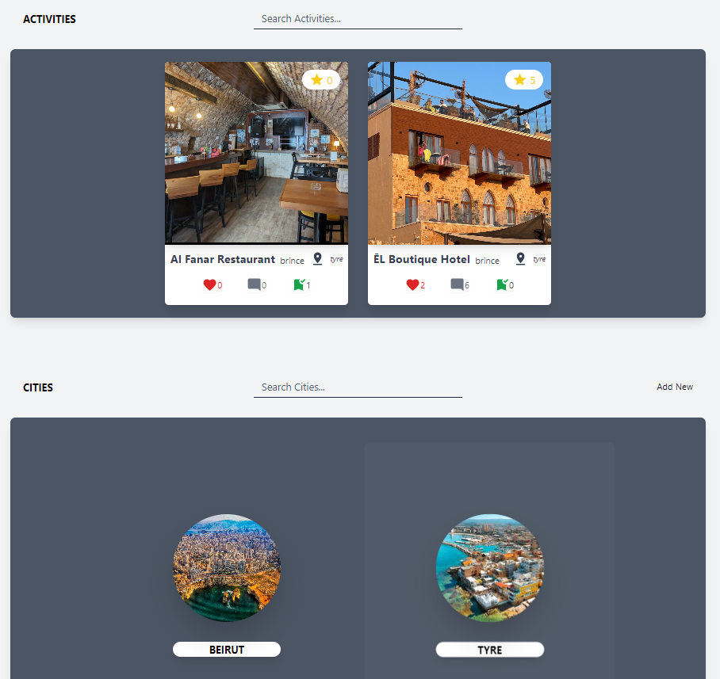

**4.3.3- Activity Types**

Activity types are categories that organize various activities within a system, with each activity being assigned to a single specific activity type to ensure clear organization. Admins can click on an activity type to view and update its details, which includes modifying the name, and the icon. Additionally, they have the option to delete an activity type if it is no longer needed, thereby removing all associated activities from the system. Admins have the capability to introduce new activity types by clicking on the ‘add new’ button, allowing for constant additions in the app.

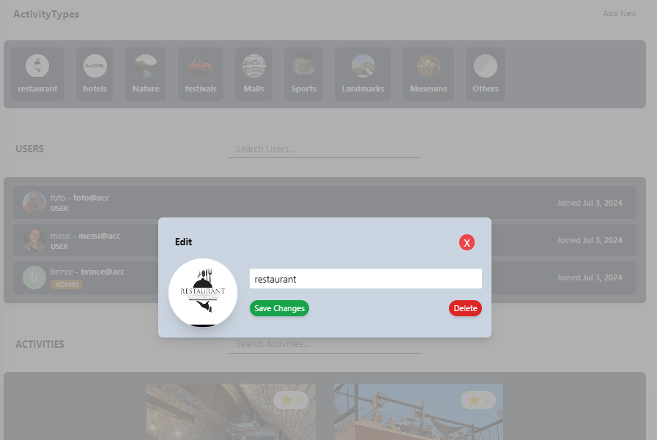

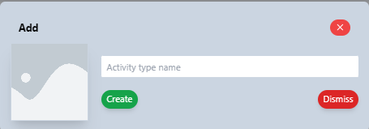

*Figure 34-**Activity Types*

**4.3.4- Users**

Admins have the capability to search for users within the system using various criteria such as user id, name, or email address. This search functionality enables admins to efficiently locate and manage users. Once a user is found, admins can click on the user to view detailed information, which may include personal details, activity history, and other relevant data.

In addition to the functionalities available to regular admins, super admins possess one more privilege. Super admins can perform the same search and viewing actions as regular admins, but they also have the authority to promote or demote users within the system. Specifically, super admins can promote regular users to admin status, granting them administrative privileges, or demote admins back to regular user status, removing their administrative capabilities.

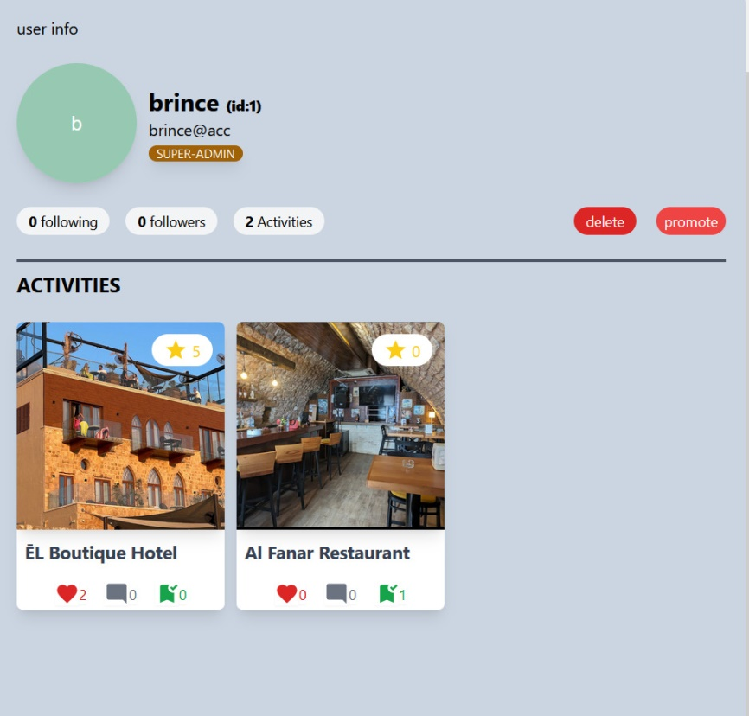

*Figure 35-**Users*

**4.3.5- Activities**

Admins have the capability to search for activities within the system using various criteria, enabling them to efficiently locate and manage specific activities. Once an activity is found, admins can click on it to view its details. This includes all aspects of the activity such as pictures, likes, comments, and ratings, providing a full view of the activity's engagement and content.

The details visibility allows admins to monitor and manage activities effectively. If an activity or any of its associated comments or ratings is deemed inappropriate, admins have the authority to delete these elements. This ensures that the content within the system remains appropriate and sticks to community guidelines. By having the ability to remove inappropriate content, admins help maintain a safe and respectful environment for all users.

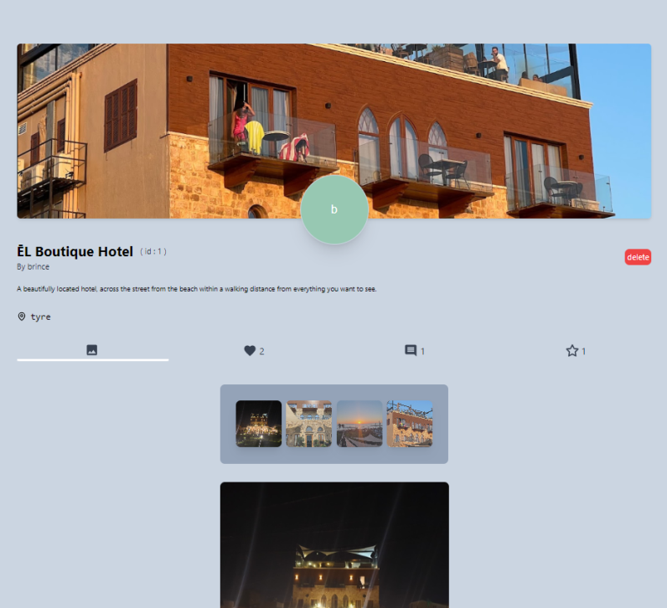

*Figure 36-**Activities*

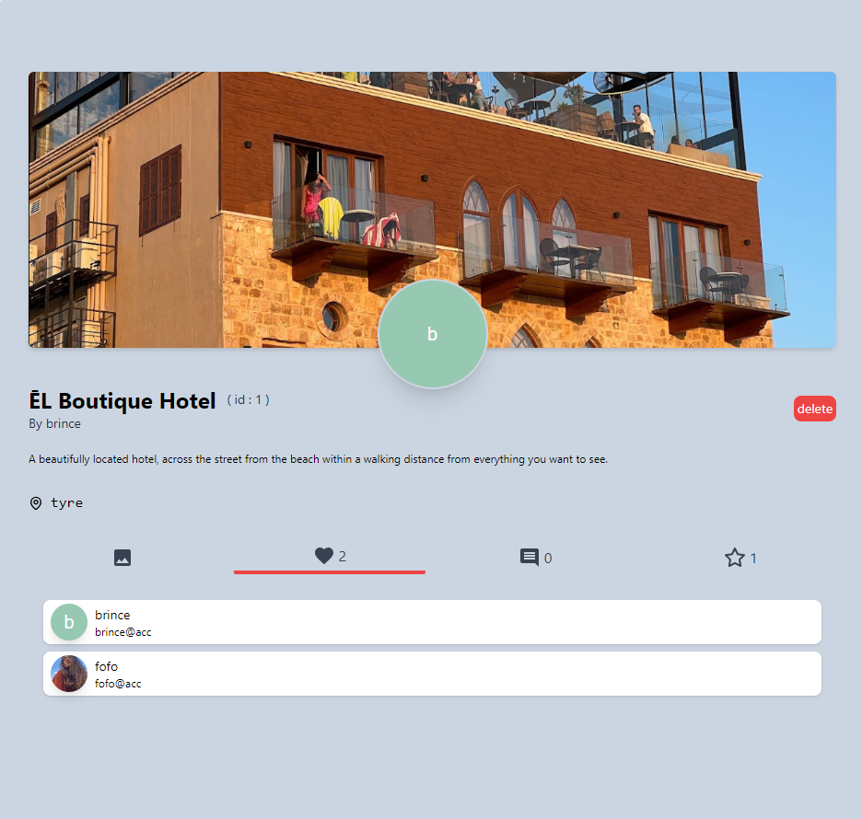

*Figure 37*

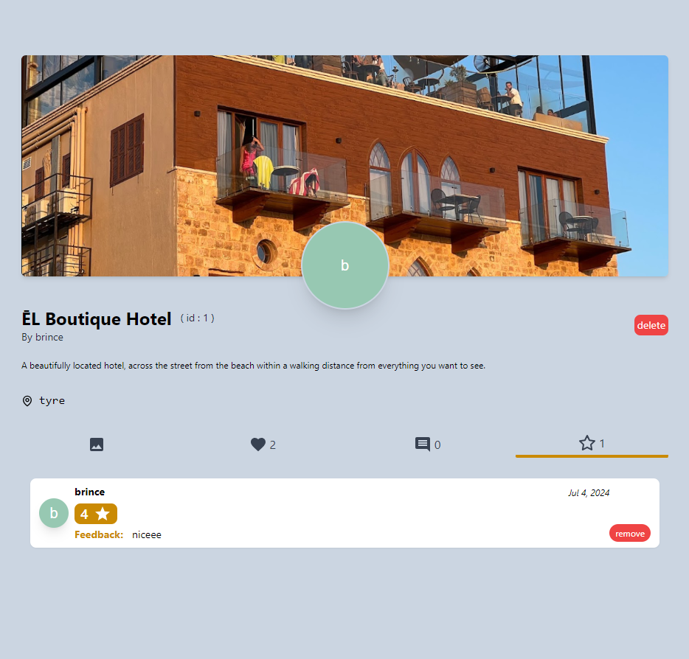

*Figure 38*

**4.3.4- Cities**

Admins have full control over the management of cities within the system, enabling them to create new cities, read or view details of existing cities, edit city information, and delete cities when necessary. This full access allows admins to ensure that the list of cities is up-to-date and relevant to the users and activities. Also, they can view detailed information about each city and its respective activities, allowing for effective oversight and management. Additionally, admins can edit city details to keep information up-to-date and delete cities that are no longer relevant, ensuring the system remains organized and accurate.

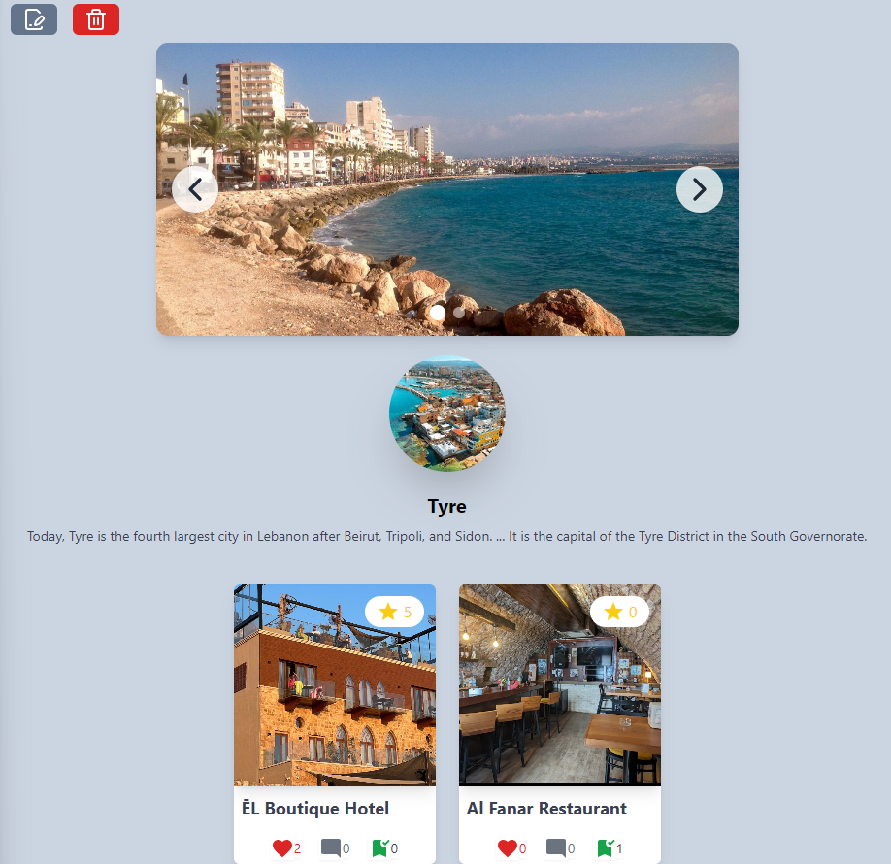

*Figure 39*

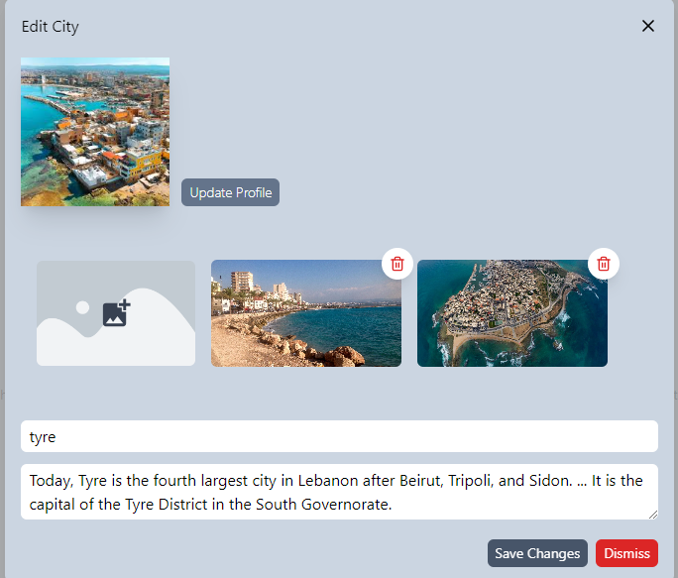

*Figure 40*

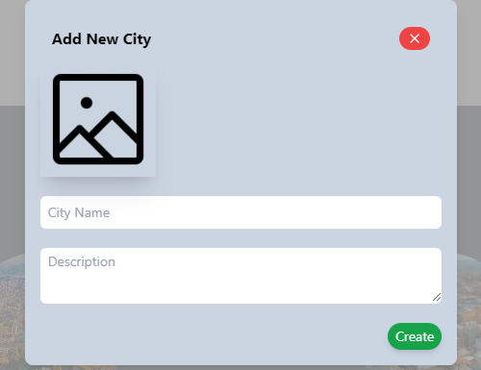

*Figure 41*

**Chapter 5:**

**5.1-Conclusion**

In conclusion, Mashwerna revolutionizes social media and tourism by addressing key deficiencies in current platforms. By fostering authentic engagement, enabling users to share genuine experiences and insights, and integrating innovative features like unbiased destination reviews, Mashwerna offers a comprehensive and enriching user experience. With a commitment to promoting tourism, facilitating meaningful interactions, and ensuring a positive environment through diligent moderation, Mashwerna paves the way for a vibrant future where everyone can enjoy authentic adventures and connect within a supportive community.

**5.2-Future Work:**

"Mashwerna" might undergo many enhancements aimed at providing users with greater customization options, improved communication features, and the integration of AI technology. Here's a glimpse of my future vision for "Mashwerna".

1. Customization: Providing users with enhanced customization options is pivotal for future iterations of Mashwerna. Introducing features that allow users to personalize their profiles, travel preferences, and feed preferences would foster a more tailored experience. This could include customizable travel itineraries, personalized travel guides based on user interests, and the ability to filter content and recommendations according to specific criteria such as budget, travel style, or destination type.
2. Communication: Enhancing communication tools within Mashwerna can facilitate more meaningful interactions among users. Integrating real-time messaging functionalities, group chat options for travel planning, and forums for discussing travel tips and experiences would encourage community engagement and foster a supportive environment. Improving communication channels between users and local businesses or tourism authorities could also facilitate seamless collaboration and information sharing.
3. AI Integration: AI integration holds immense potential for Mashwerna evolution. By incorporating AI-driven analytics, the platform can analyze user behavior, trends, and preferences to continuously refine its recommendation algorithms. This could include predictive analytics for travel trends, sentiment analysis of user reviews to ensure authenticity, and automated content moderation to maintain a positive user experience. Moreover, AI can assist in detecting and preventing fraudulent activities, ensuring the integrity of user-generated content and reviews.

**References**

1. Flutter Documentation:  
   a. Flutter. "Flutter Documentation." Accessed April 1, 2024.  
   <https://docs.flutter.dev/>  
   b. YouTube - Dart Language:  
   <https://www.youtube.com/watch?v=kgN7veo9tC0&list=PL93xoMrxRJIsYc9L0XBSaiiuq01JTMQ_o>  
   c. YouTube - Basic Flutter:  
   <https://www.youtube.com/watch?v=FVgQcfXHeGo&list=PLeWmXrh004782w91CeXQ4bK8ivREDau-x>
2. Laravel Documentation:  
   a. Laravel. "Laravel Documentation." Accessed April 1, 2024.  
   [https://laravel.com/docs/11.x/readmes](https://v17.angular.io/docs)

b. Youtube - Hosting Laravel on 000webhost:

<https://www.youtube.com/watch?v=2kOZUjKa9OE>

1. React.js Documentation:  
   React.js. "React.js Documentation." Accessed April 1, 2024.  
   <https://react.dev/learn>
2. TailwindCSS Documentation:  
   TailwindCSS. "TailwindCSS Documentation." Accessed April 1, 2024.  
   <https://v2.tailwindcss.com/docs>
3. Design Inspiration for Applications and Websites:  
   a. Pinterest: <https://www.pinterest.com/>  
   b. Google Images